Student Performance Prediction System

Project Id: AIML-5

Name : Anushka Diwaker (Team Leader)
Class Roll Number: 32
University Roll Number : 2028654
Section and Group: G, G1

Name : Jayna Kothari
Class Roll Number: 10
University Roll Number : 2028438
Section and Group: G, G1

- Problem Description 3
- Architecture 4
- Models model 5
- Evaluation metrics used 6
- Preliminary Results and Visualizations 7
- References 8

- Problem Description

Design and develop an end-to-end machine learning system to predict user movie preferences based on Netflix user rating history. The project should involve selecting a suitable dataset containing user IDs, movie IDs, ratings, and timestamps. Preprocessing should include handling missing values, cleaning duplicate records, normalization of rating values, and transformation of categorical attributes (user/movie IDs encoding). Relevant features such as user viewing behavior, movie popularity, genre, and historical rating patterns should be identified using feature selection techniques. The system should include model training using Logistic Regression, KNN, and SVM classifiers to classify user preference categories (such as Like/Dislike or High Rating/Low Rating). The models should be evaluated using classification performance metrics including accuracy, precision, recall, F1-score, confusion matrix, and ROC curve. The project should demonstrate a complete ML pipeline from raw rating dataset to evaluated predictive models. Expected Output: 1 : High Rating / Recommended 0 : Low Rating / Not Recommended

- Architecture

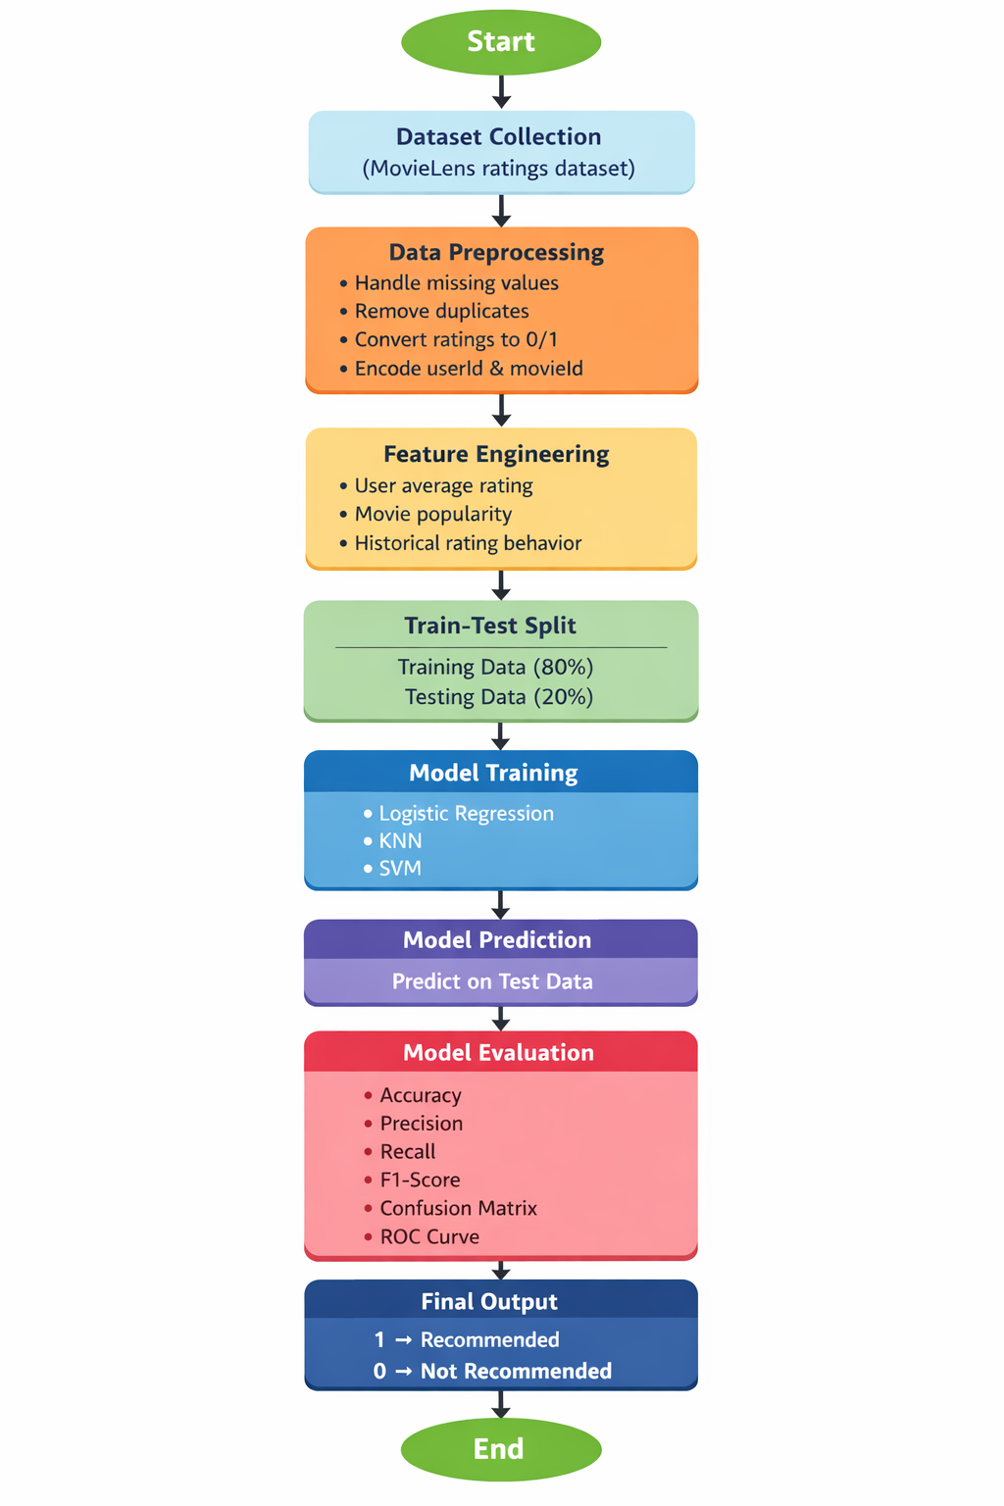
Fig.1 flow diagram.

- Models Used(Applied/ Planned) Give a brief introduction of the models use

In this project, three supervised machine learning classification models were applied to predict user movie preferences: Logistic Regression, K-Nearest Neighbors (KNN), and Support Vector Machine (SVM). These models were selected because they represent different learning approaches and provide a comprehensive comparison of performance.

Logistic Regression is a statistical model used for binary classification problems. It predicts the probability that a given input belongs to a particular class. In this project, it is used to classify movies as High Rating (1) or Low Rating (0). It serves as a baseline model due to its simplicity, interpretability, and efficiency.

K-Nearest Neighbors (KNN) is a non-parametric, instance-based learning algorithm. It classifies a data point based on the majority class of its nearest neighbors in the feature space. The value of K (number of neighbors) was optimized using the elbow method by analyzing the error rate for different values. KNN is particularly useful for capturing local patterns in the data.

Support Vector Machine (SVM) is a powerful classification algorithm that finds the optimal hyperplane to separate data points of different classes. It is effective in high-dimensional spaces and can handle non-linear relationships using kernel functions. In this project, SVM is used to achieve better generalization and classification performance.

Together, these models allow comparison between linear (Logistic Regression), distance-based (KNN), and margin-based (SVM) approaches for predicting user preferences.

- Evaluation metrics used

To evaluate the performance of the models, several standard classification metrics were used:

Accuracy measures the overall correctness of the model by calculating the ratio of correctly predicted observations to the total observations. It provides a general idea of model performance.

Precision measures the proportion of correctly predicted positive observations out of all predicted positives. It indicates how reliable the positive predictions are.

Recall (Sensitivity) measures the proportion of actual positive cases that were correctly identified by the model. It reflects the model’s ability to detect relevant instances.

F1-Score is the harmonic mean of precision and recall. It provides a balance between precision and recall, especially useful when the dataset is imbalanced.

Confusion Matrix is a tabular representation of actual vs predicted values. It provides detailed insight into:
- True Positives (TP)
- True Negatives (TN)
- False Positives (FP)
- False Negatives (FN)
This helps in understanding where the model is making errors.

ROC Curve (Receiver Operating Characteristic Curve) is a graphical representation of the model’s performance across different classification thresholds. It plots the True Positive Rate (Recall) against the False Positive Rate.

AUC (Area Under Curve) measures the area under the ROC curve. A higher AUC value indicates better model performance in distinguishing between classes.

5. Preliminary Results and Visualizations
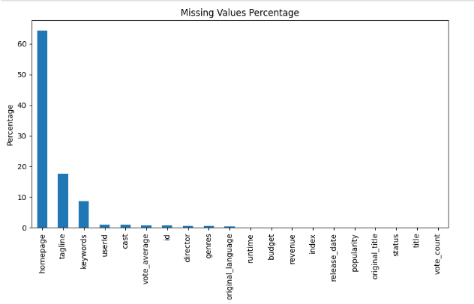
Fig.2

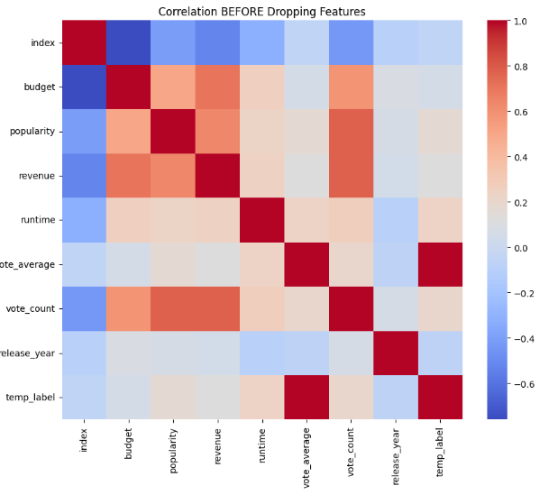
Fig.3
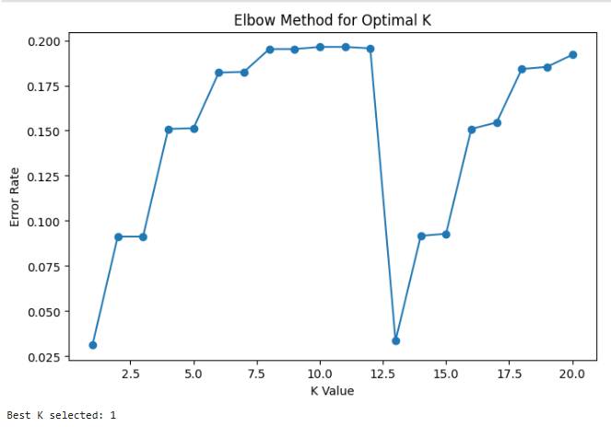
Fig.4

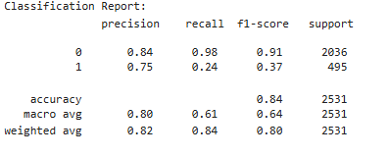

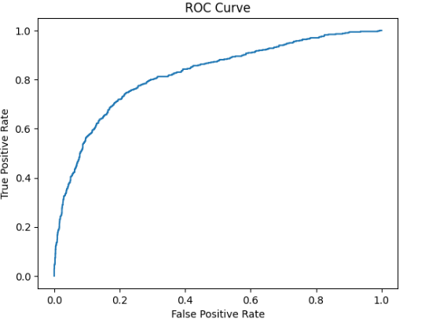
Fig.4

6. References:
Books:
- Let Us Python – Yashavant Kanetkar

Machine Learning tutorials and examples from:
  - GeeksforGeeks (https://www.geeksforgeeks.org/)
  - Towards Data Science articles
  - Kaggle notebooks and datasets

Online Resources:
  - TutorialsPoint – https://www.tutorialspoint.com/cprogramming/index.htm
  - Stack Overflow – https://stackoverflow.com

